



**Investigación Libre: Sección de Comentarios Anónimos**

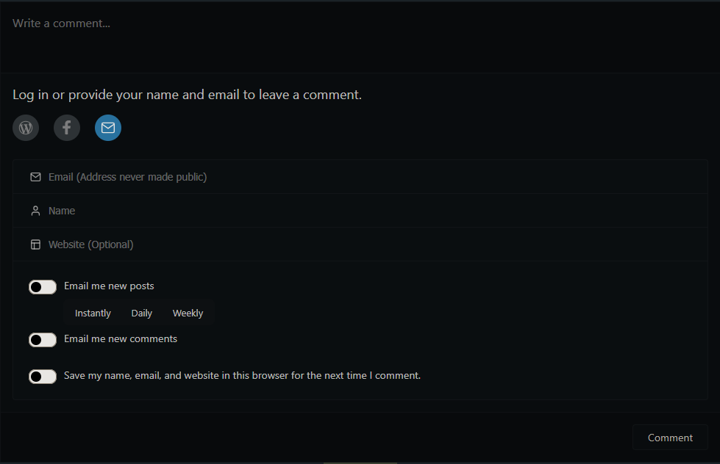

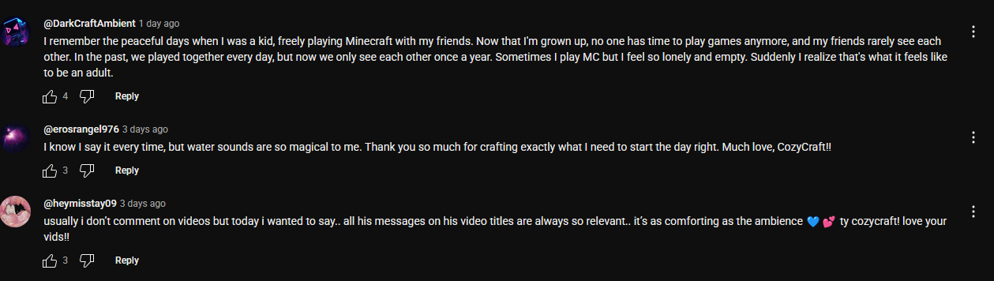

<https://albumreviews.blog/reviews/1970s-album-reviews/townes-van-zandt/>

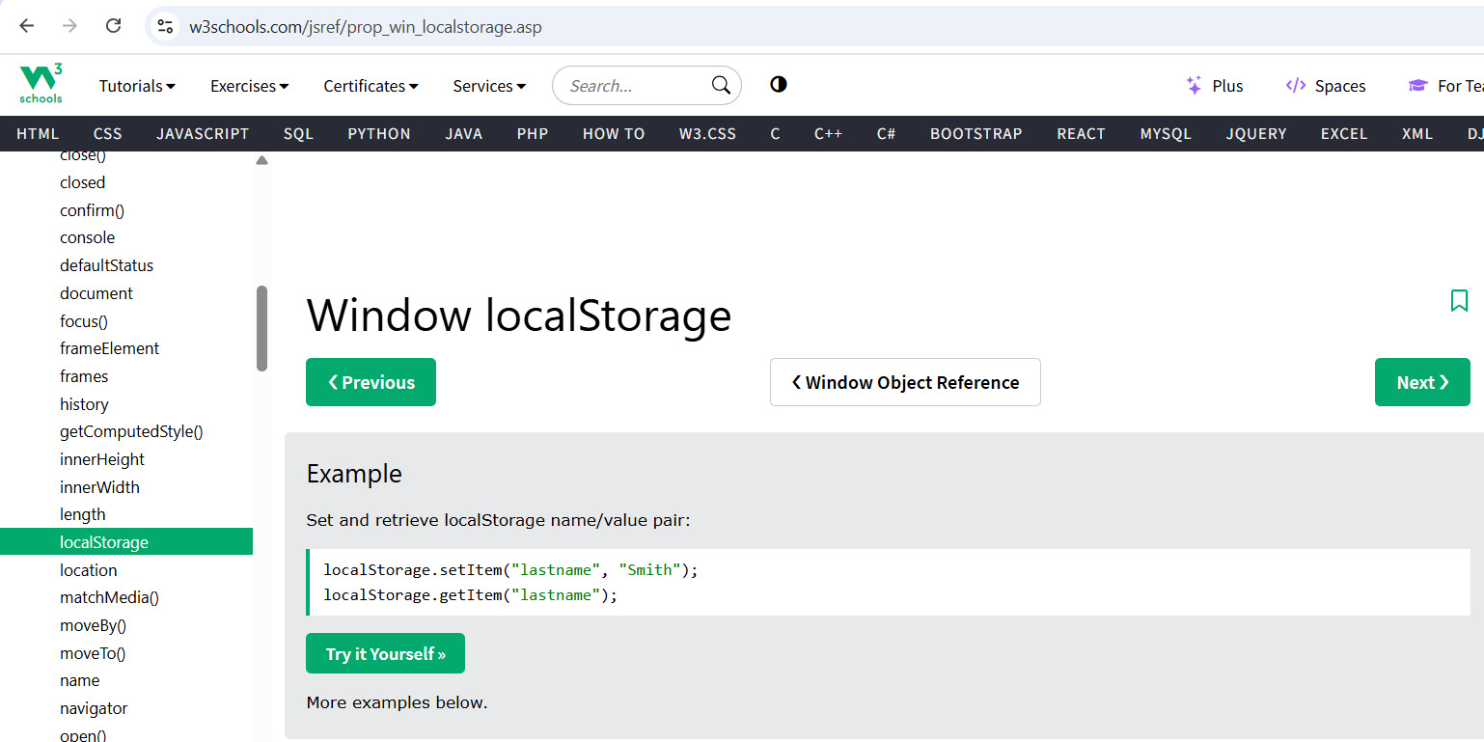

<https://www.w3schools.com/jsref/prop_win_localstorage.asp>

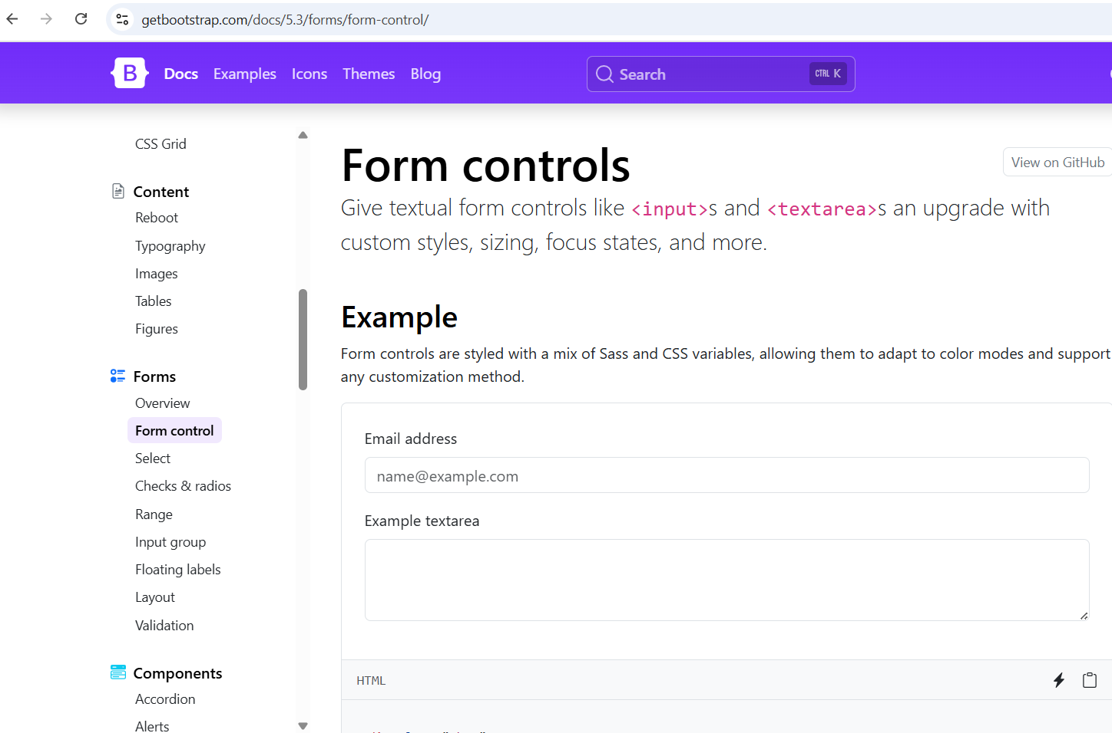

<https://getbootstrap.com/docs/5.3/forms/form-control/>

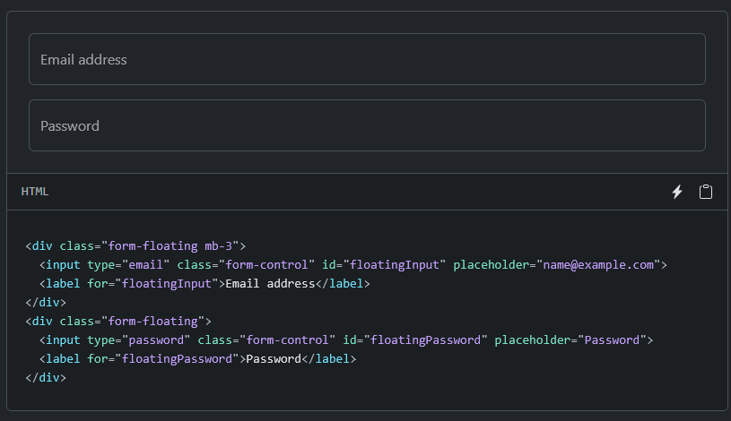

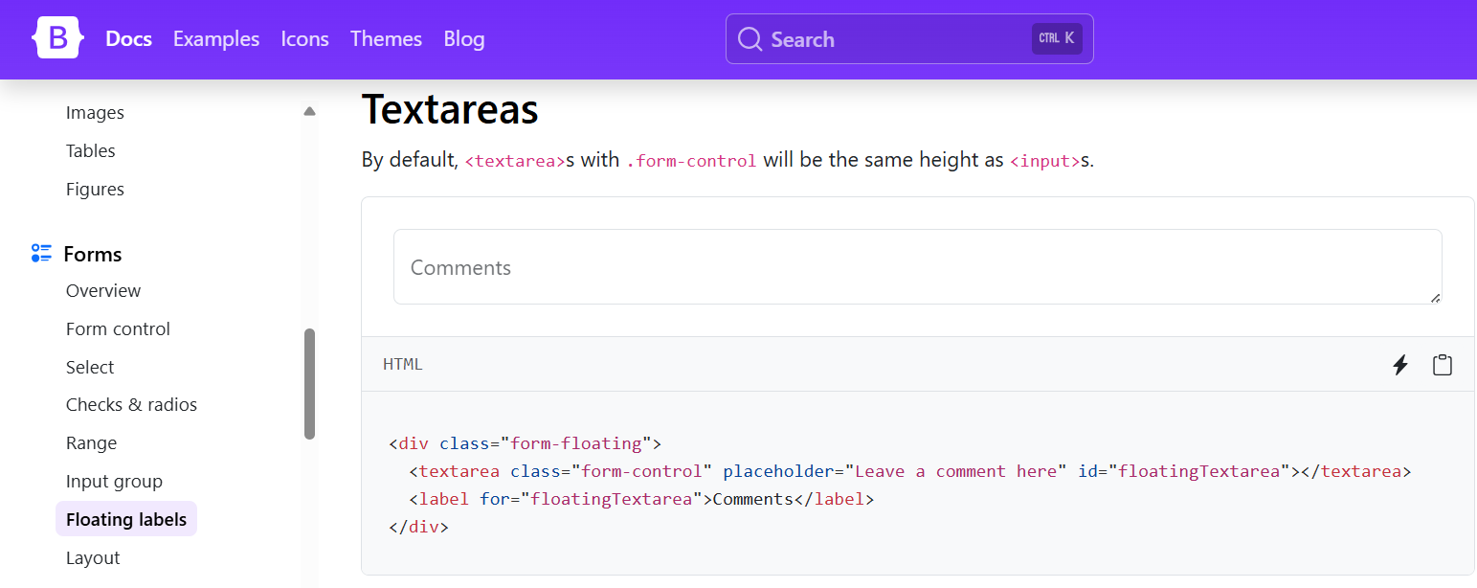

<https://getbootstrap.com/docs/5.3/forms/floating-labels/>

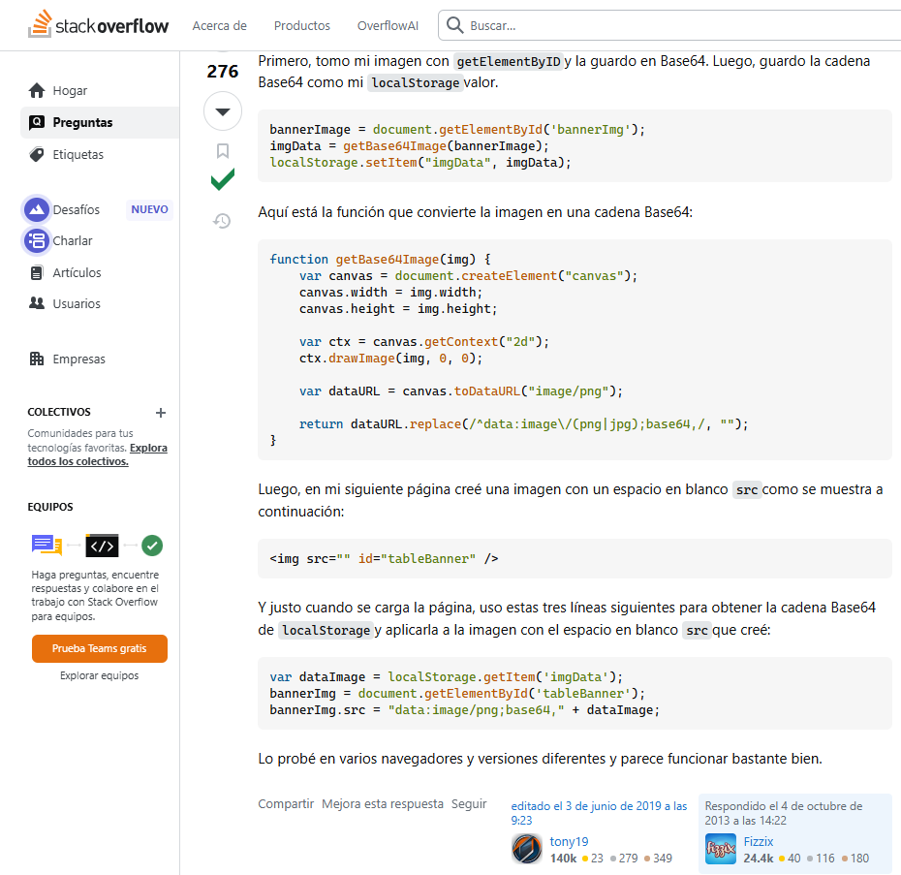

<https://stackoverflow.com/questions/19183180/how-to-save-an-image-to-localstorage-and-display-it-on-the-next-page>

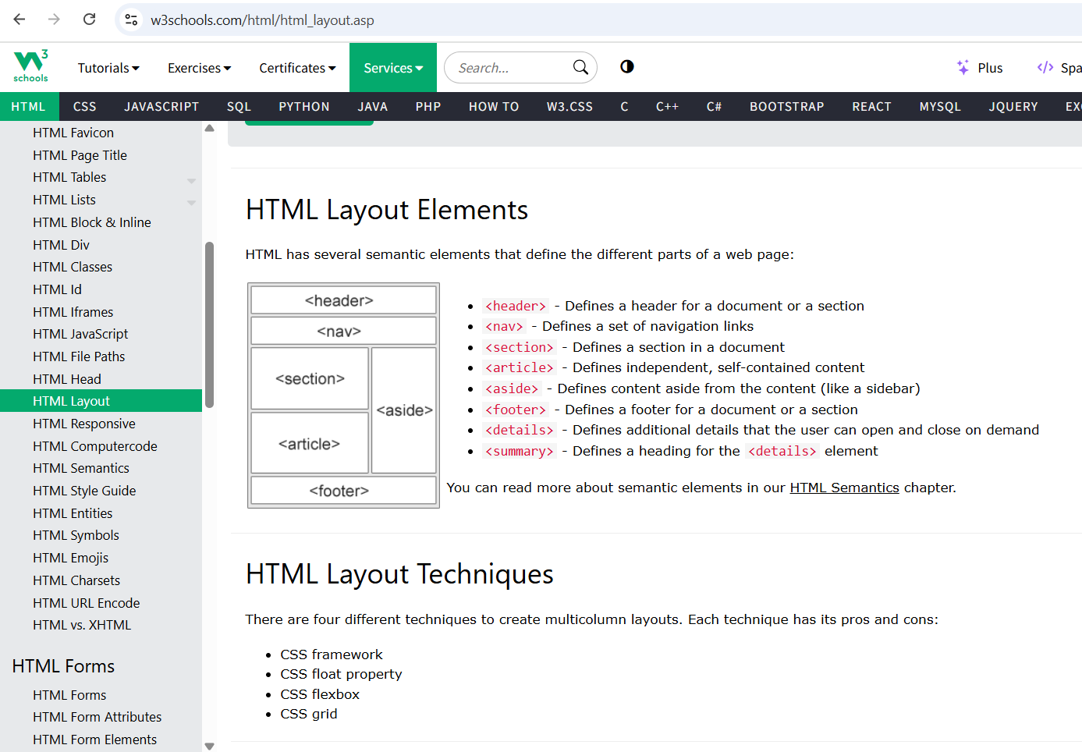

<https://www.w3schools.com/html/html_layout.asp> 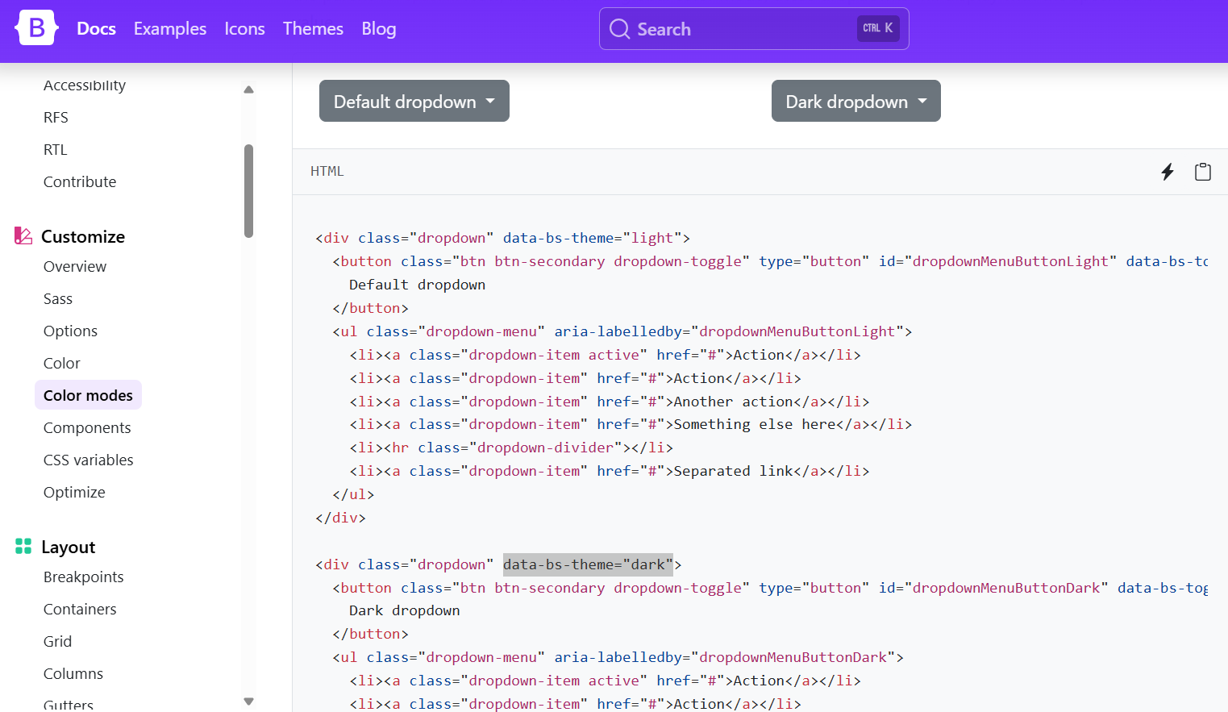

<https://getbootstrap.com/docs/5.3/customize/color-modes/>

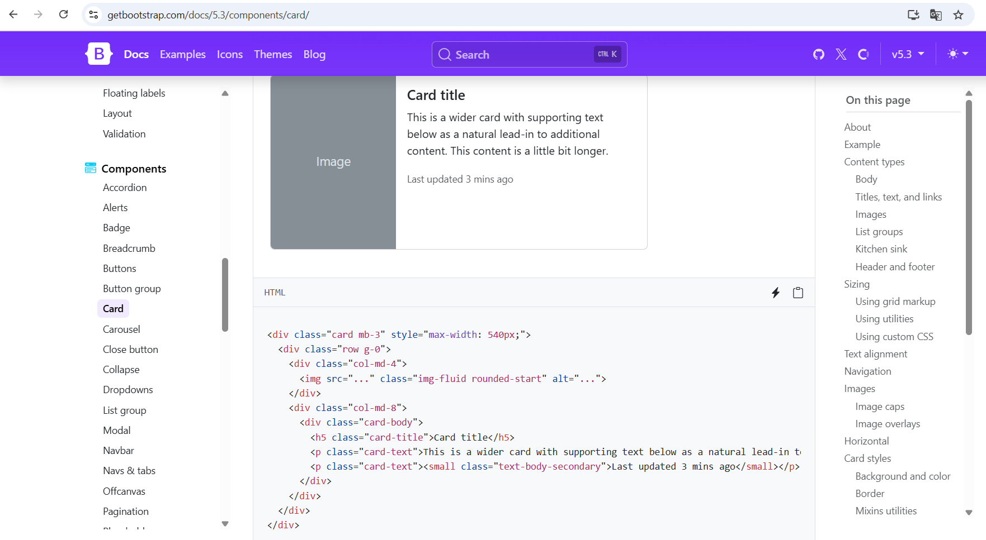

<https://getbootstrap.com/docs/5.3/components/card/>

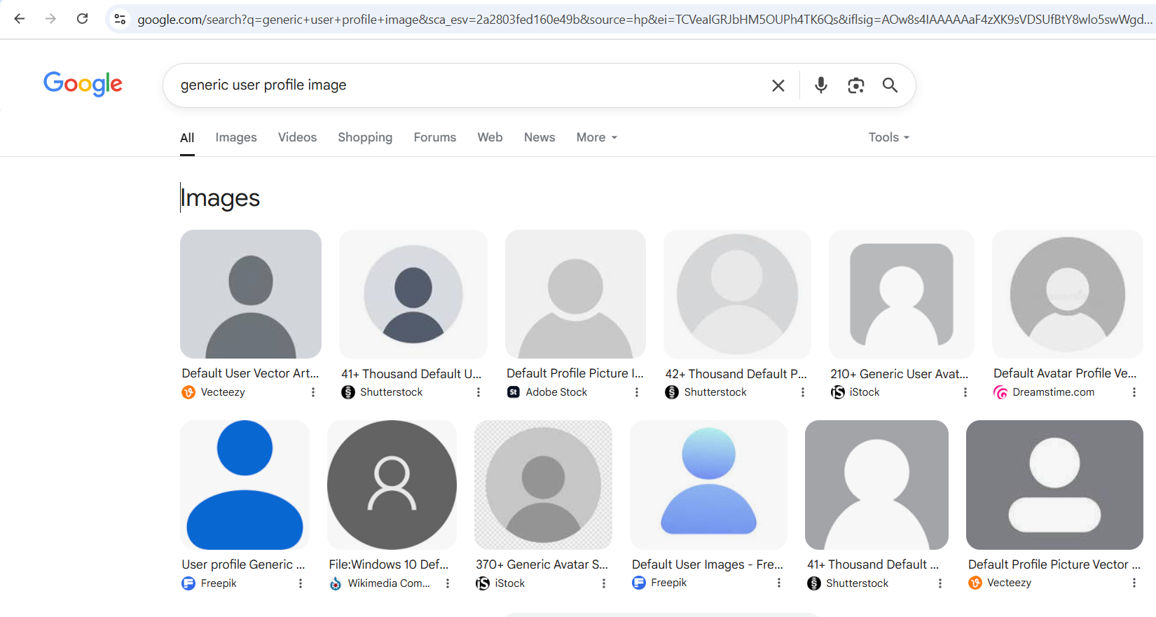

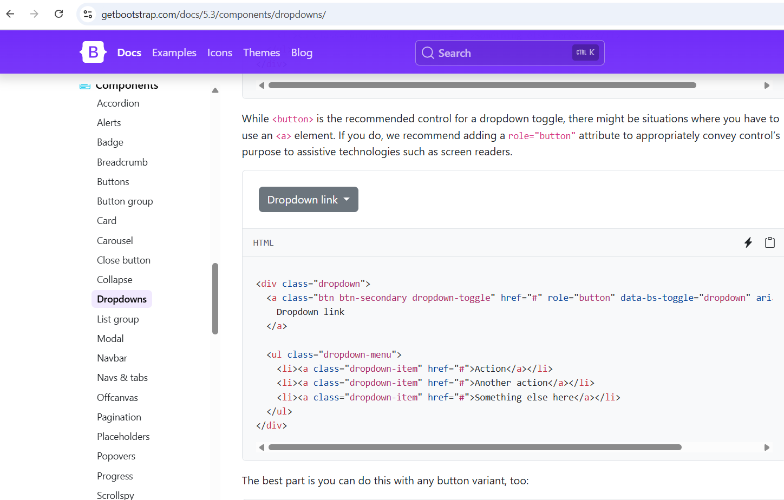

<https://getbootstrap.com/docs/5.3/components/dropdowns/>

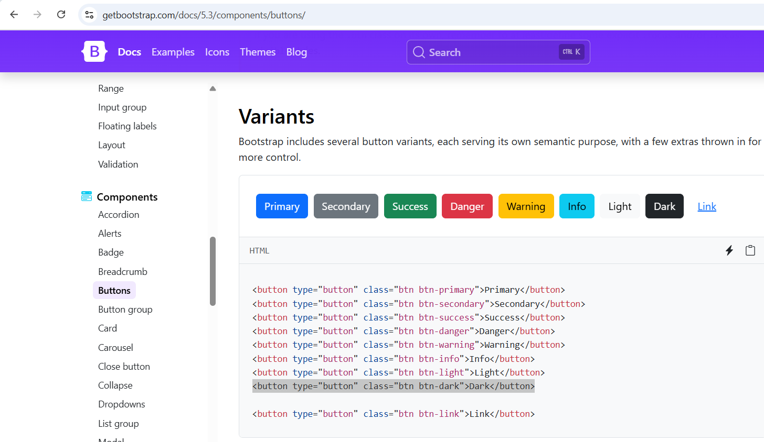

<https://getbootstrap.com/docs/5.3/components/buttons/>

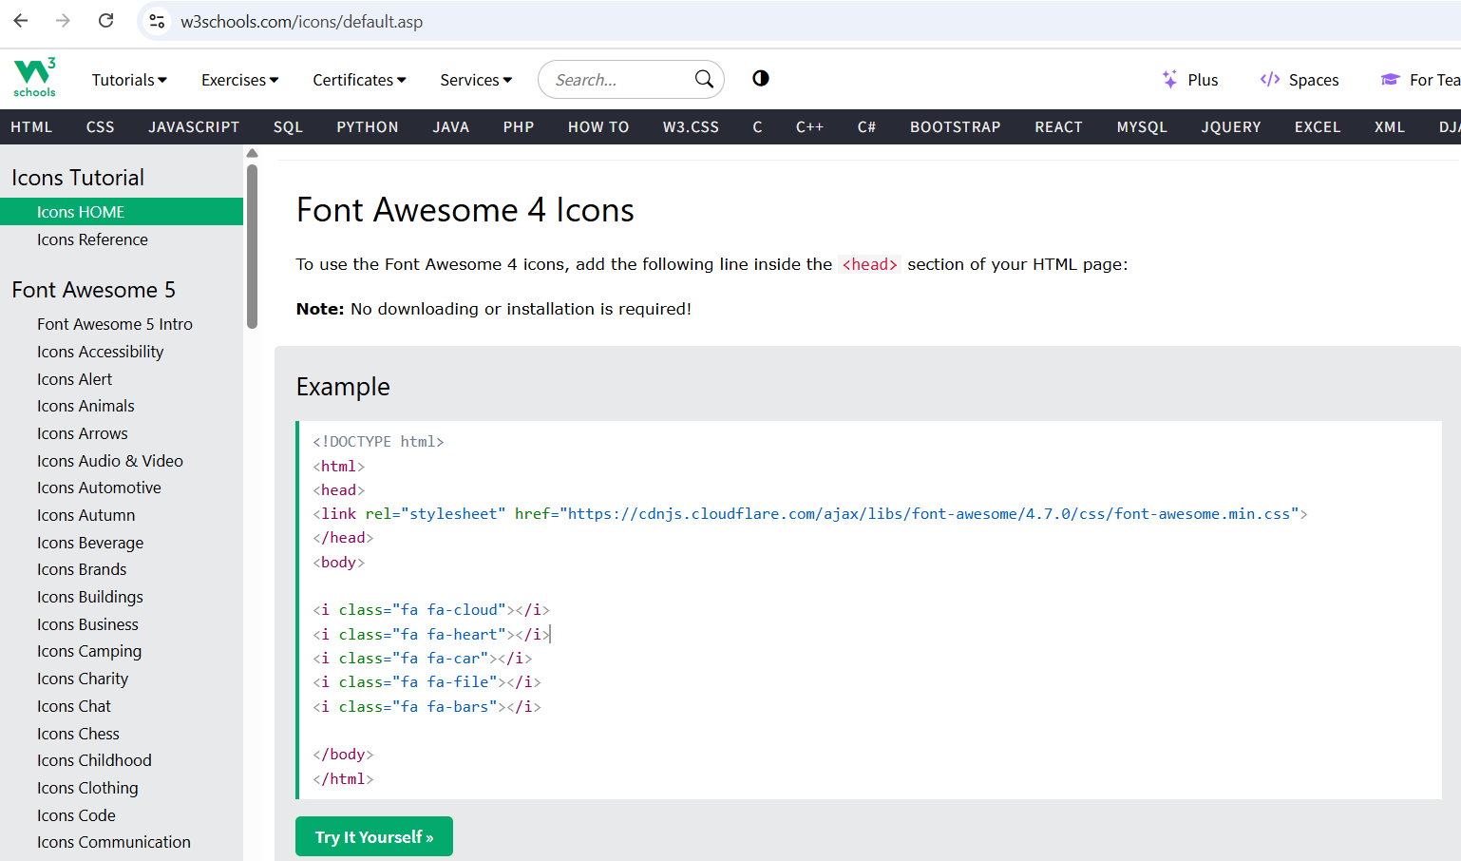

<https://www.w3schools.com/icons/default.asp>

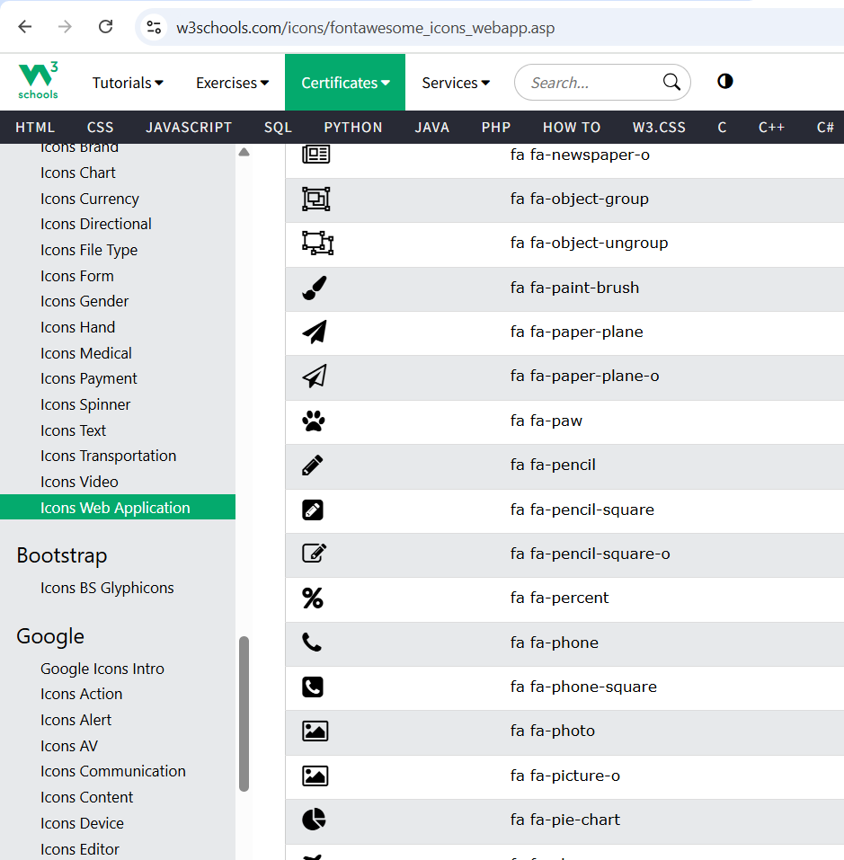

<https://www.w3schools.com/icons/fontawesome_icons_webapp.asp>

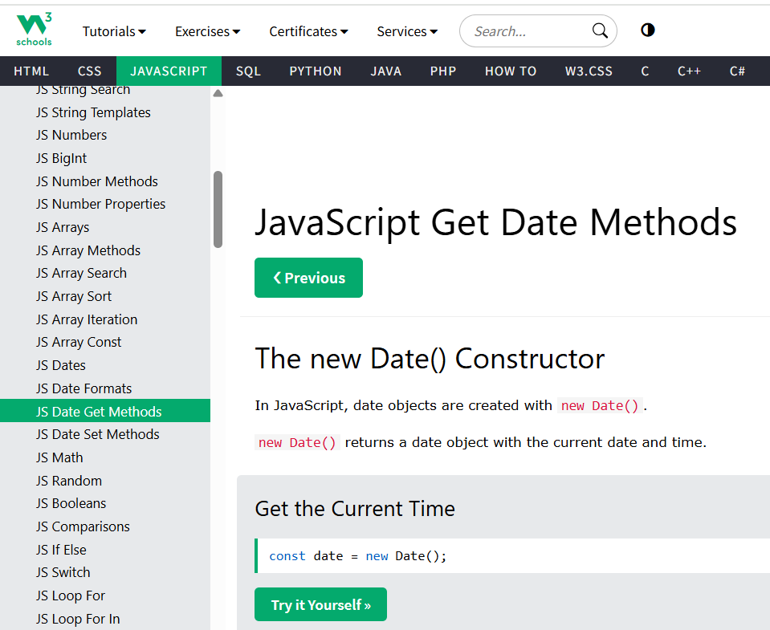

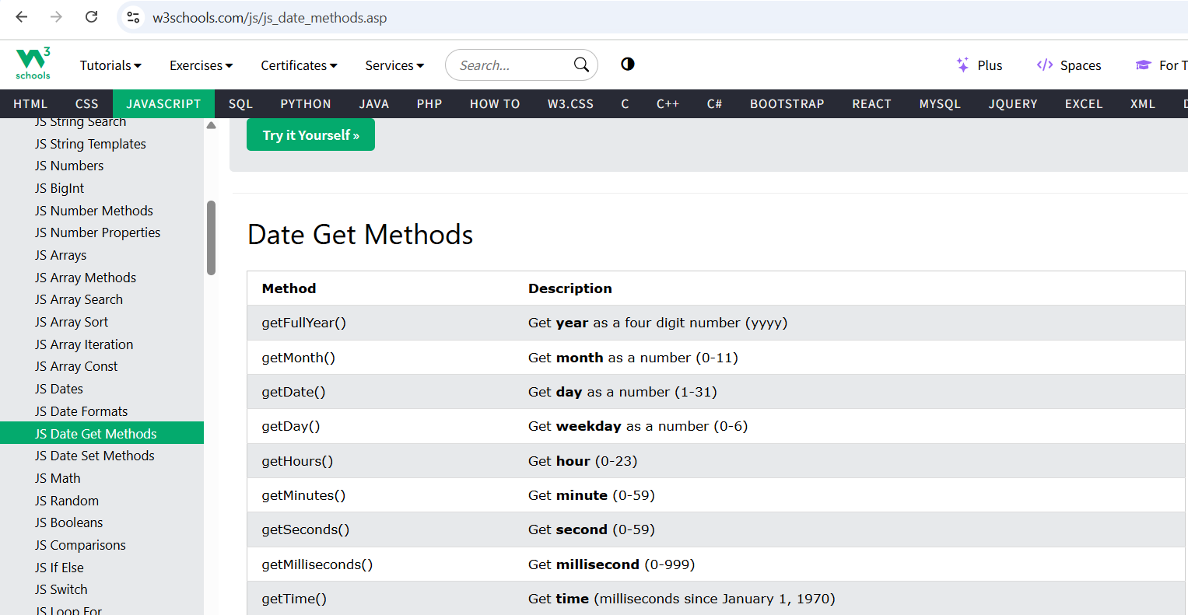

<https://www.w3schools.com/js/js_date_methods.asp>

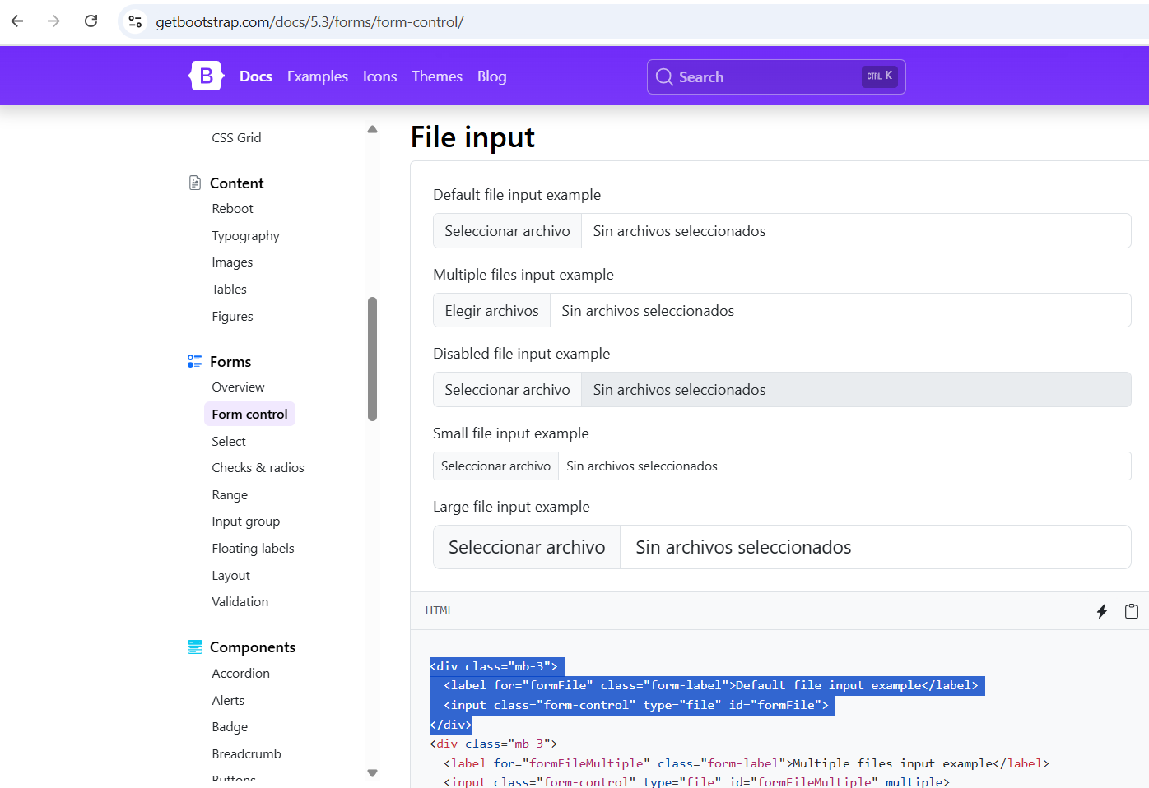

<https://getbootstrap.com/docs/5.3/forms/form-control/>

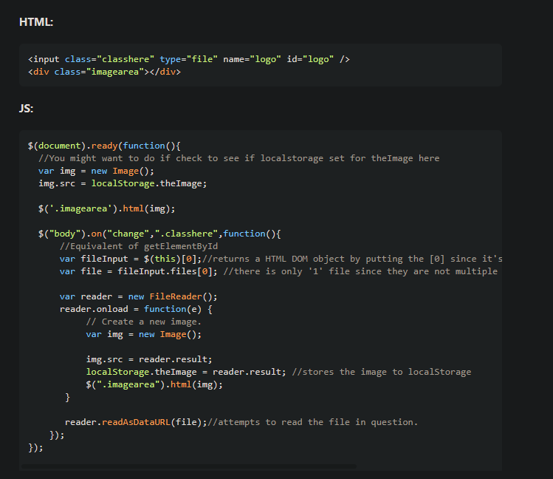

<https://stackoverflow.com/questions/19119040/how-do-i-save-and-restore-a-file-object-in-local-storage>

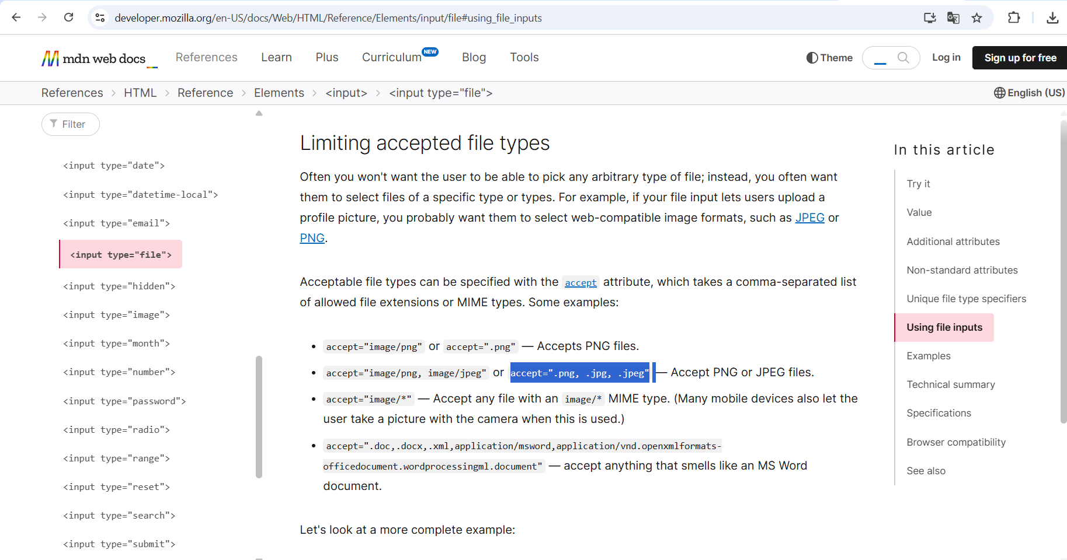

<https://developer.mozilla.org/en-US/docs/Web/HTML/Reference/Elements/input/file#using_file_inputs>